Red text needs to be updated for each individual entity (for example if you do not have police and fire then delete these references).

Blue text needs to be updated.

**Note X - Pension Plan**

**General Information about the Pension Plan**

**Plan Description**

Employees of the City are provided with pensions through the Oregon Public Employees Retirement System (OPERS) a cost-sharing multiple-employer defined benefit pension plan, the Oregon Legislature has delegated authority to the Public Employees Retirement Board to administer and manage the system. All benefits of the System are established by the legislature pursuant to ORS Chapters 238 and 238A. Tier One/Tier Two Retirement Benefit plan, established by ORS Chapter 238, is closed to new members hired on or after August 29, 2003. The Pension Program, established by ORS Chapter 238A, provides benefits to members hired on or after August 29, 2003. OPERS issues a publicly available Comprehensive Annual Financial Report and Actuarial Valuation that can be obtained at <http://www.oregon.gov/pers/Pages/Financials/Actuarial-Financial-Information.aspx>.

**Benefits Provided**

1. **Tier One/Tier Two Retirement Benefit ORS Chapter 238**

**Pension Benefits**

The PERS retirement allowance is payable monthly for life. It may be selected from 13 retirement benefit options. These options include survivorship benefits and lump-sum refunds. The basic benefit is based on years of service and final average salary. A percentage (2.0 percent for police and fire employees, 1.67 percent for general service employees) is multiplied by the number of years of service and the final average salary. Benefits may also be calculated under either a formula plus annuity (for members who were contributing before August 21, 1981) or a money match computation if a greater benefit results.

A member is considered vested and will be eligible at minimum retirement age for a service retirement allowance if he or she has had a contribution in each of five calendar years or has reached at least 50 years of age before ceasing employment with a participating employer (age 45 for police and fire members). General service employees may retire after reaching age 55. Police and fire members are eligible after reaching age 50. Tier One general service employee benefits are reduced if retirement occurs prior to age 58 with fewer than 30 years of service. Police and fire member benefits are reduced if retirement occurs prior to age 55 with fewer than 25 years of service. Tier Two members are eligible for full benefits at age 60. The ORS Chapter 238 Defined Benefit Pension Plan is closed to new members hired on or after August 29, 2003.

**Death Benefits**

Upon the death of a non-retired member, the beneficiary receives a lump-sum refund of the member’s account balance (accumulated contributions and interest). In addition, the beneficiary will receive a lump-sum payment from employer funds equal to the account balance, provided one or more of the following conditions are met:

* the member was employed by a PERS employer at the time of death,
* the member died within 120 days after termination of PERS-covered employment,
* the member died as a result of injury sustained while employed in a PERS-covered job, or
* the member was on an official leave of absence from a PERS-covered job at the time of death.

**Disability Benefits**

A member with 10 or more years of creditable service who becomes disabled from other than duty-connected causes may receive a non-duty disability benefit. A disability resulting from a job-incurred injury or illness qualifies a member (including PERS judge members) for disability benefits regardless of the length of PERS-covered service. Upon qualifying for either a non-duty or duty disability, service time is computed to age 58 (55 for police and fire members) when determining the monthly benefit.

**Benefit Changes After Retirement**

Members may choose to continue participation in a variable equities investment account after retiring and may experience annual benefit fluctuations due to changes in the market value of equity investments. Under ORS 238.360 monthly benefits are adjusted annually through cost-of-living (COLA) changes. The COLA is capped at 2.0 percent.

1. **OPSRP Defined Benefit Pension Program (OPSRP DB)**

**Pension Benefits**

The Pension Program (ORS Chapter 238A) provides benefits to members hired on or after August 29, 2003. This portion of OPSRP provides a life pension funded by employer contributions. Benefits are calculated with the following formula for members who attain normal retirement age:

Police and fire: 1.8 percent is multiplied by the number of years of service and the final average salary. Normal retirement age for police and fire members is age 60 or age 53 with 25 years of retirement credit. To be classified as a police and fire member, the individual must have been employed continuously as a police and fire member for at least five years immediately preceding retirement.

General service: 1.5 percent is multiplied by the number of years of service and the final average salary. Normal retirement age for general service members is age 65, or age 58 with 30 years of retirement credit.

A member of the OPSRP Pension Program becomes vested on the earliest of the following dates: the date the member completes 600 hours of service in each of five calendar years, the date the member reaches normal retirement age, and, if the pension program is terminated, the date on which termination becomes effective.

**Death Benefits**

Upon the death of a non-retired member, the spouse or other person who is constitutionally required to be treated in the same manner as the spouse, receives for life 50 percent of the pension that would otherwise have been paid to the deceased member.

**Disability Benefits**

A member who has accrued 10 or more years of retirement credits before the member becomes disabled or a member who becomes disabled due to job-related injury shall receive a disability benefit of 45 percent of the member’s salary determined as of the last full month of employment before the disability occurred.

**Benefit Changes After Retirement**

Under ORS 238A.210 monthly benefits are adjusted annually through cost-of-living changes. Under current law, the cap on the COLA in fiscal year 2015 and beyond will vary based on 1.25 percent on the first $60,000 of annual benefit and $750 plus 0.15 percent on annual benefits above $60,000.

1. **OPSRP Individual Account Program (OPSRP IAP)**

**Pension Benefits**

The IAP is an individual account-based program under the PERS tax-qualified governmental plan as defined under ORS 238A.400. An IAP member becomes vested on the date the employee account is established or on the date the rollover account was established. If the employer makes optional employer contributions for a member, the member becomes vested on the earliest of the following dates: the date the member completes 600 hours of service in each of five calendar years, the date the member reaches normal retirement age, the date the IAP is terminated, the date the active member becomes disabled, or the date the active member dies.

Upon retirement, a member of the OPSRP Individual Account Program (IAP) may receive the amounts in his or her employee account, rollover account, and vested employer account as a lump-sum payment or in equal installments over a 5-, 10-, 15-, 20-year period or an anticipated life span option. Each distribution option has a $200 minimum distribution limit.

**Death Benefits**

Upon the death of a non-retired member, the beneficiary receives in a lump sum the member’s account balance, rollover account balance, and vested employer optional contribution account balance. If a retired member dies before the installment payments are completed, the beneficiary may receive the remaining installment payments or choose a lump-sum payment.

**Recordkeeping**

OPERS contracts with VOYA Financial to maintain IAP participant records.

**Contributions**

1. **Employer Contributions**

PERS funding policy provides for monthly employer contributions at actuarially determined rates. These contributions, expressed as a percentage of covered payroll, are intended to accumulate sufficient assets to pay benefits when due. This funding policy applies to the PERS Defined Benefit Plan and the Other Postemployment Benefit Plans. Employer contribution rates during the period were based on the December 31, 2015 actuarial valuation. The rates based on a percentage of payroll, first became effective July 1, 2017. Employer contributions for the year ended June 30, 2020 were $178,898, excluding amounts to fund employer specific liabilities. The rates in effect for the fiscal year ended June 30, 2020 were 35.28 percent for Tier One/Tier Two General Service Member, 35.28 percent for Tier One/Tier Two Police and Fire, 26.44 percent for OPSRP Pension Program General Service Members, 31.07 percent for OPSRP Pension Program Police and Fire Members.

1. **Employee Contributions**

Beginning January 1, 2004, all employee contributions were placed in the OPSRP Individual Account Program (IAP), a defined contribution pension plan established by the Oregon Legislature. Prior to that date, all member contributions were credited to the Defined Benefit Pension Plan. Member contributions are set by statute at 6.0 percent of salary and are remitted by participating employers. The contributions are either deducted from member salaries or paid by the employers on the members behalf. The IAP member accounts represent member contributions made on or after January 1, 2004, plus earnings allocations less disbursements for refunds, death benefits, and retirements. As permitted, the City has opted to pick-up the contributions on behalf of employees; contribution were $42,442 for the year ended June 30, 2020.

**Pension Assets, Liabilities, Pension Expense, and Deferred Outflows of Resources and Deferred Inflows of Resources Related to Pensions**

At June 30, 2020, the City reported a liability of $1,473,628 for its proportionate share of the net pension liability. The net pension liability was measured as of June 30, 2019, and the total pension liability used to calculate the net pension liability was determined by an actuarial valuation as of December 31, 2017 rolled forward to June 30, 2019. The City's proportion of the net pension liability was based on a projection of the City's long-term share of contributions to the pension plan relative to the projected contributions of all participating entities, actuarially determined. At June 30, 2019, the City's proportion was 0.00852 percent, which was increased from its proportion of 0.00647 percent measured as of June 30, 2018.

For the year ended June 30, 2020, the City's recognized pension expense of $434,370. At June 30, 2020, the City reported deferred outflows of resources and deferred inflows of resources related to pensions from the following sources:



City’s contributions subsequent to the measurement date of $178,898 are reported as deferred outflows of resources related to pensions and will be recognized as a reduction of the net pension liability in the year ended June 30, 2021. Other amounts reported as deferred outflows of resources and deferred inflows of resources related to pensions will be recognized in pension expense as follows:



**Actuarial Assumptions**

The total pension liability in the December 31, 2017 actuarial valuation was determined using the following actuarial assumptions:



Actuarial valuations of an ongoing plan involve estimates of the value of projected benefits and assumptions about the probability of events far into the future. Actuarially determined amounts are subject to continual revision as actual results are compared to past expectations and new estimates are made about the future. Experience studies are performed as of December 31 of even numbered years. The methods and assumptions shown above are based on the 2016 Experience Study which reviewed experience for the four-year period ending on December 31, 2016.

**Long-term Expected Rate of Return**

To develop an analytical basis for the selection of the long-term expected rate of return assumption, in July 2017 the PERS Board reviewed long-term assumptions developed by both Milliman’s capital market assumptions team and the Oregon Investment Council’s (OIC) investment advisors. The table below shows Milliman’s assumptions for each of the asset classes in which the plan was invested at that time based on the OIC long-term target asset allocation. The OIC’s description of each asset class was used to map the target allocation to the asset classes shown below. Each asset class assumption is based on a consistent set of underlying assumptions and includes adjustment for the inflation assumption. These assumptions are not based on historical returns, but instead are based on a forward-looking capital market economic model.

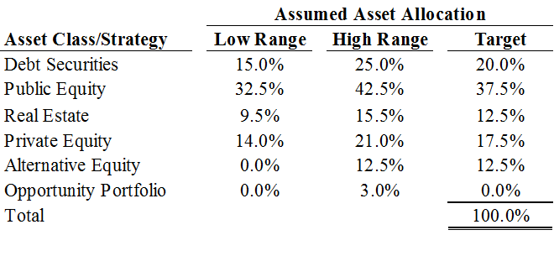

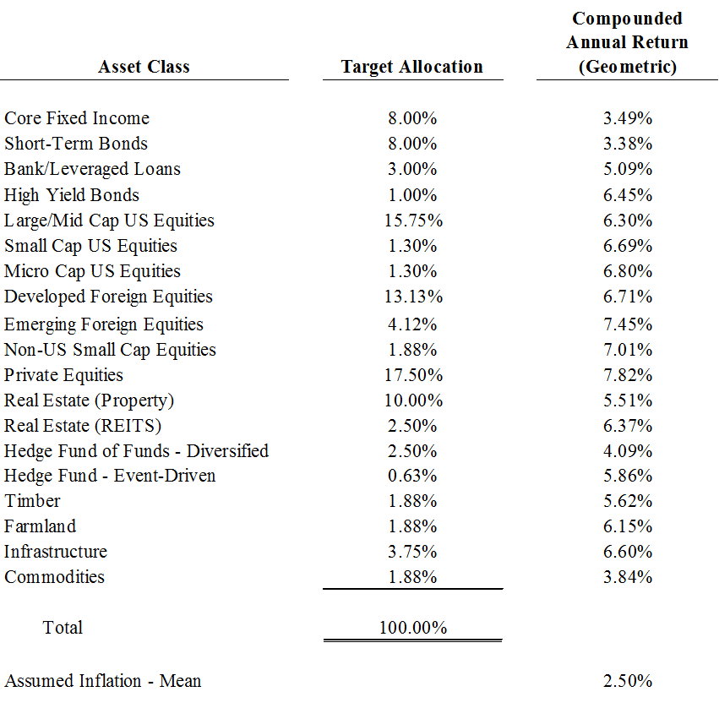

**Depletion Date Projection**

GASB 68 generally requires that a blended discount rate be used to measure the Total Pension Liability (the Actuarial Accrued Liability calculated using the Individual Entry Age Normal Cost Method). The long-term expected return on plan investments may be used to discount liabilities to the extent that the plan’s Fiduciary Net Position is projected to cover benefit payments and administrative expenses. A 20-year high quality (AA/Aa or higher) municipal bond rate must be used for periods where the Fiduciary Net Position is not projected to cover benefit payments and administrative expenses. Determining the discount rate under GASB 68 will often require that the actuary perform complex projections of future benefit payments and pension plan investments. GASB 68 (paragraph 67) does allow for alternative evaluations of projected solvency, if such evaluation can reliably be made. GASB does not contemplate a specific method for making an alternative evaluation of sufficiency; it is left to professional judgment.

The following circumstances justify an alternative evaluation of sufficiency for PERS:

* PERS has a formal written policy to calculate an Actuarially Determined Contribution (ADC), which is articulated in the actuarial valuation report.
* The ADC is based on a closed, layered amortization period, which means that payment of the full ADC each year will bring the plan to a 100% funded position by the end of the amortization period if future experience follows assumption.
* GASB 68 specifies that the projections regarding future solvency assume that plan assets earn the assumed rate return and there are no future changes in the plan provisions or actuarial methods and assumptions, which means that the projections would not reflect any adverse future experience which might impact the plan’s funded position.

Based on these circumstances, it is our independent actuary’s opinion that the detailed depletion date projections outlined in GASB 68 would clearly indicate that the Fiduciary Net Position is always projected to be sufficient to cover benefit payments and administrative expenses.

**Discount Rate**

The discount rate used to measure the total pension liability was 7.20 percent for the Defined Benefit Pension Plan. The projection of cash flows used to determine the discount rate assumed that contributions from plan members and those of the contributing employers are made at the contractually required rates, as actuarially determined. Based on those assumptions, the pension plan’s fiduciary net position was projected to be available to make all projected future benefit payments of current plan members. Therefore, the long-term expected rate of return on pension plan investments for the Defined Benefit Pension Plan was applied to all periods of projected benefit payments to determine the total pension liability.

**Sensitivity of the City's Proportionate Share of the Net Pension Liability to Changes in the Discount Rate**

The following presents the City's proportionate share of the net pension liability calculated using the discount rate of 7.20 percent, as well as what the City's proportionate share of the net pension liability would be if it were calculated using a discount rate that is 1-percentage-point lower (6.20 percent) or 1-percentage-point higher (8.20 percent) than the current rate:



**Pension Plan Fiduciary Net Position**

Detailed information about the pension plan's fiduciary net position is available in the separately issued OPERS financial report.

**Payables to the Pension Plan**

[If the District reported payables to the defined benefit pension plan, it should disclose information required by paragraph 122 of this Statement.]

**Changes in Plan Provisions During the Measurement Period**

There were no changes during the June 30, 2019 measurement period that require disclosure.

**Changes in Plan Provisions Subsequent to Measurement Date**

A legislative change that occurred after the December 31, 2017 valuation date affected the plan provisions reflected for financial reporting purposes. Senate Bill 1049, signed into law in June 2019, introduced a limit on the amount of annual salary included for the calculation of benefits. Beginning in 2020, annual salary in excess of $195,000 (as indexed in future years) will be excluded when determining member benefits. As a result, future Tier 1/Tier 2 and OPSRP benefits for certain active members are now projected to be lower than prior to the legislation. Senate Bill 1049 was reflected in the June 30, 2019 Total Pension Liability as a reduction in liability.

**Notes to Required Supplementary Information**

**Changes in Benefit Terms**

The 2013 Oregon Legislature made a series of changes to PERS that lowered projected future benefit payments from the System. These changes included reductions to future Cost of Living Adjustments (COLA) made through Senate Bills 822 and 861. Senate Bill 822 also required the contribution rates scheduled to be in effect from July 2013 to June 2015 to be reduced. The Oregon Supreme Court decision in Moro v. State of Oregon, issued on April 30, 2015, reversed a significant portion of the reductions the 2013 Oregon Legislature made to future System Cost of Living Adjustments (COLA) through Senate Bills 822 and 861. This reversal increased the total pension liability as of June 30, 2015 compared to June 30, 2014 total pension liability.

A legislative change that occurred after the December 31, 2017 valuation date affected the plan provisions reflected for financial reporting purposes. Senate Bill 1049, signed into law in June 2019, introduced a limit on the amount of annual salary included for the calculation of benefits. Beginning in 2020, annual salary in excess of $195,000 (as indexed in future years) will be excluded when determining member benefits. As a result, future Tier 1/Tier 2 and OPSRP benefits for certain active members are now projected to be lower than prior to the legislation. Senate Bill 1049 was reflected in the June 30, 2019 Total Pension Liability as a reduction in liability.

**Changes of Assumptions**

The PERS Board adopted assumption changes that were used to measure the June 30, 2016 total pension liability. The changes include the lowering of the long-term expected rate of return to 7.50 percent and lowering of the assumed inflation to 2.50 percent. In addition, the healthy mortality assumption was changed to reflect an updated mortality improvement scale for all groups, and assumptions were updated for merit increases, unused sick leave, and vacation pay were updated. For June 30, 2018, the long-term expected rate of return was lowered to 7.20 percent. In addition, the healthy mortality assumption was changed to reflect an updated mortality improvement scale for all groups, and assumptions were updated for merit increases, unused sick leave, and vacation pay were updated.